Exercise 1- OOP

|  |
| --- |
| Cat |
| Breed  Color  Body type  Character |
| eat()  sleep()  walk()  jump()  sit()  climb()  run() |

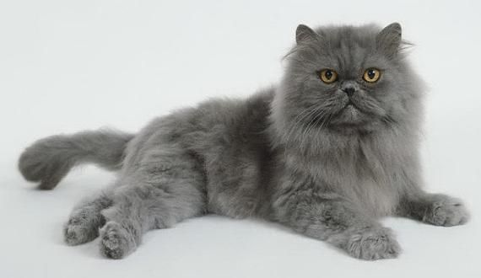

Breed : Persian cat

Color : Gray

Body type: Short

Character: Smart, docile, elegant

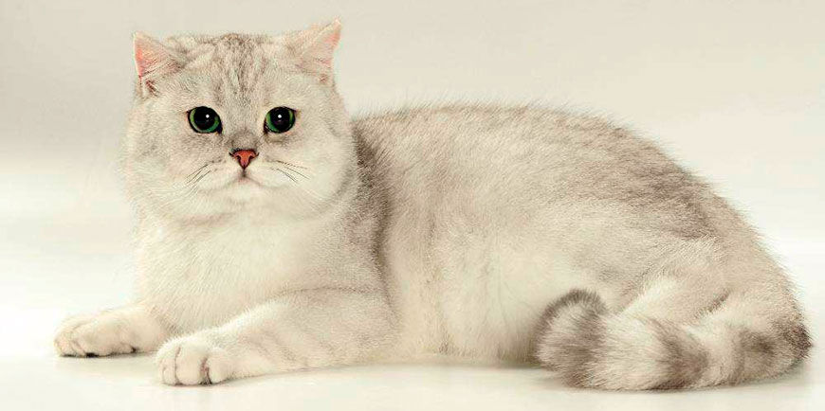

Breed : British shorthair cat

Color : White

Body type: Chubby

Character: Bold, curious, docile

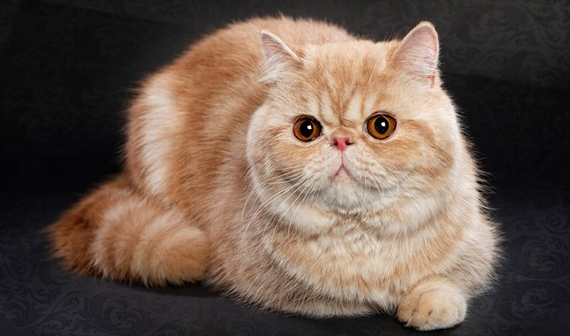

Breed : Exotic shorthair cat

Color : Fawn

Body type: Medium size,short,fat

Character: Quiet,playful,curious

|  |
| --- |
| Dog |
| Breed  Color  Body type  Character |
| eat()  sleep()  walk()  jump()  sit()  climb()  run() |

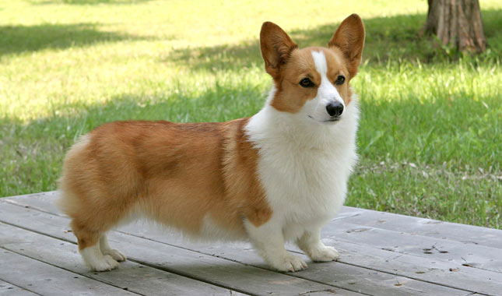

Breed : Welsh Corgi Pembroke

Color : Fawn

Body type: Small

Character: Friendly,bold,brave

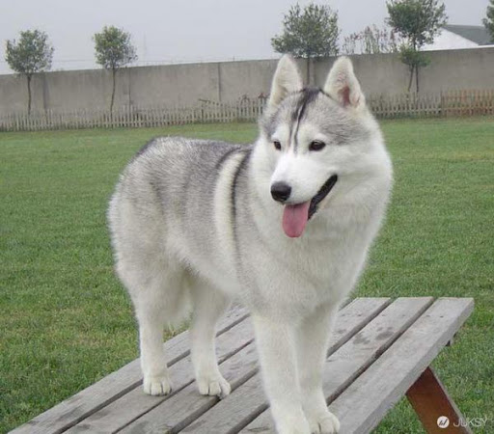

Breed : Siberian Husky

Color : White

Body type: Medium

Character: Friendly,enthusiastic

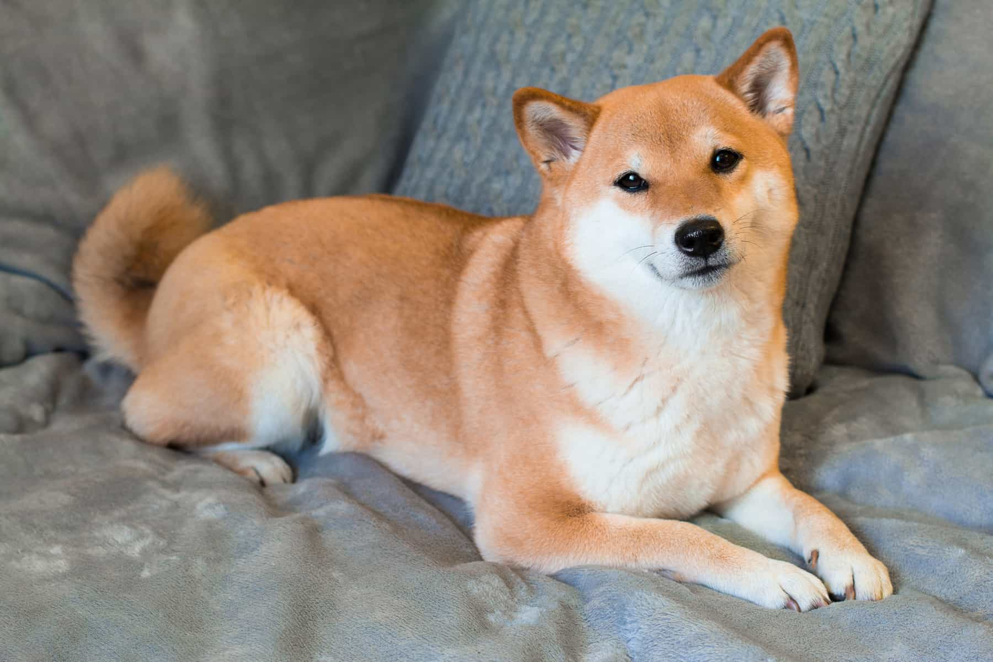

Breed : Shiba Inu (Japan)

Color : Fawn

Body type: Medium

Character: Loyal,obedient,patient

|  |
| --- |
| Person |
| Name  Age  Gender |
| eat()  sleep()  work()  walk()  sit()  study() |

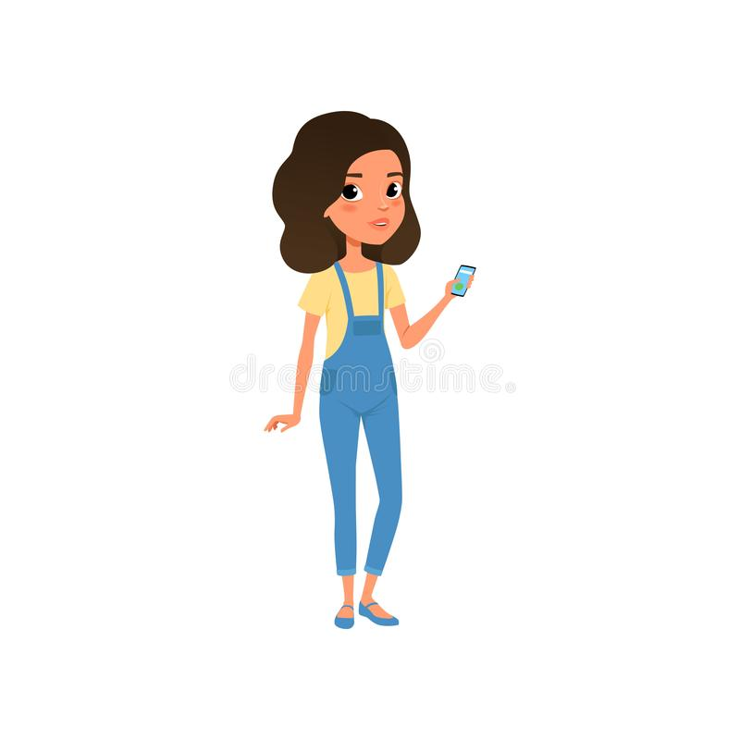

Name : Victoria

Age : 18

Gender: Female

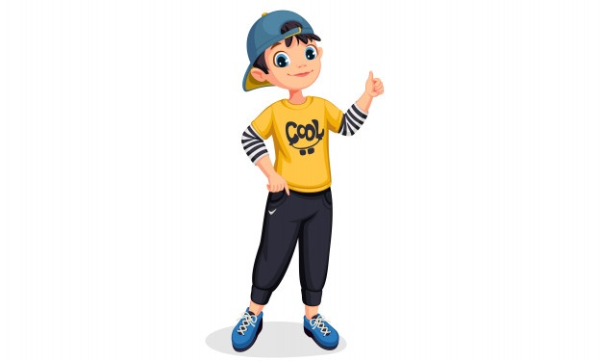

Name : Oscar

Age : 18

Gender: Male

|  |
| --- |
| Cell phone |
| Brand  Color  Model |
| speed()  size()  quality() |

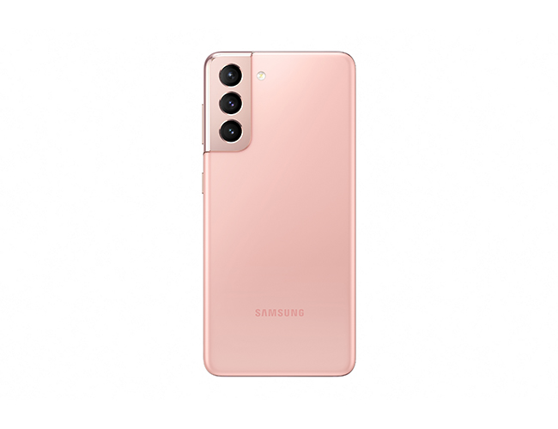

Model : Galaxy S21

Color : Phantom Pink

Brand : Samsung

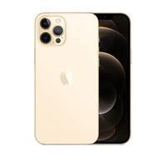

Model : Pro Max

Color : Gold

Brand : iPhone

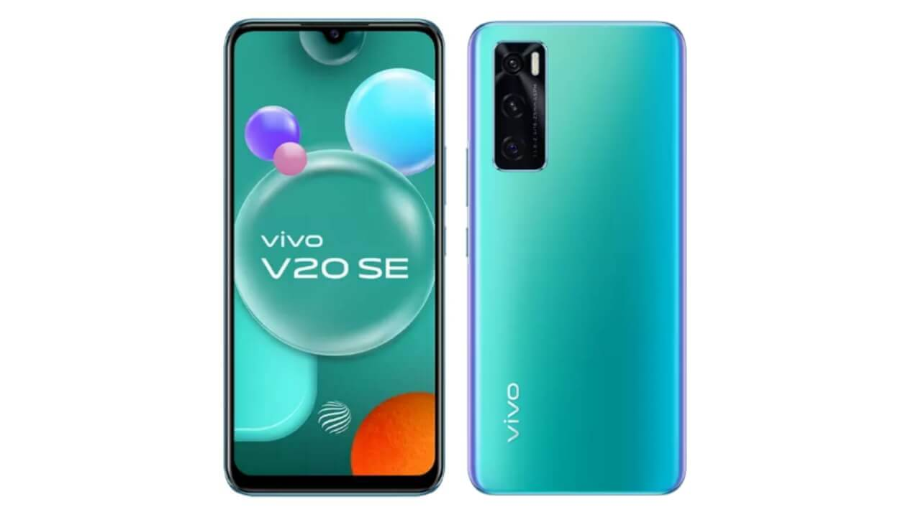

Model : V20 SE

Color : Aquamarine Green

Brand : Vivo

|  |
| --- |
| Laptop |
| Brand  Color  Model |
| speed()  size()  quality() |

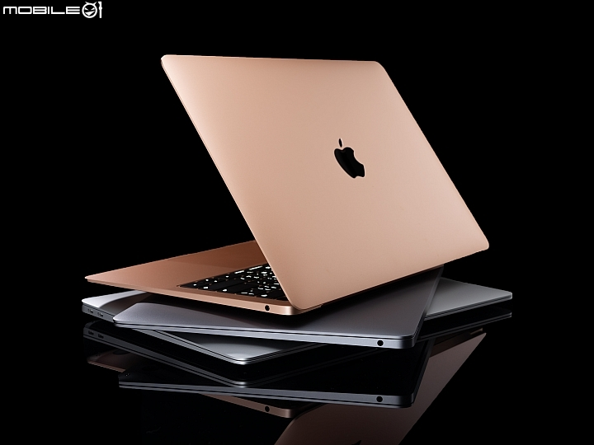

Model : MacBook Air

Color : Gold

Brand : Apple

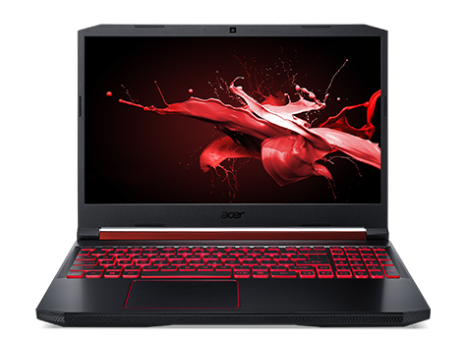

Model : NITRO 5

Color : Black

Brand : Acer

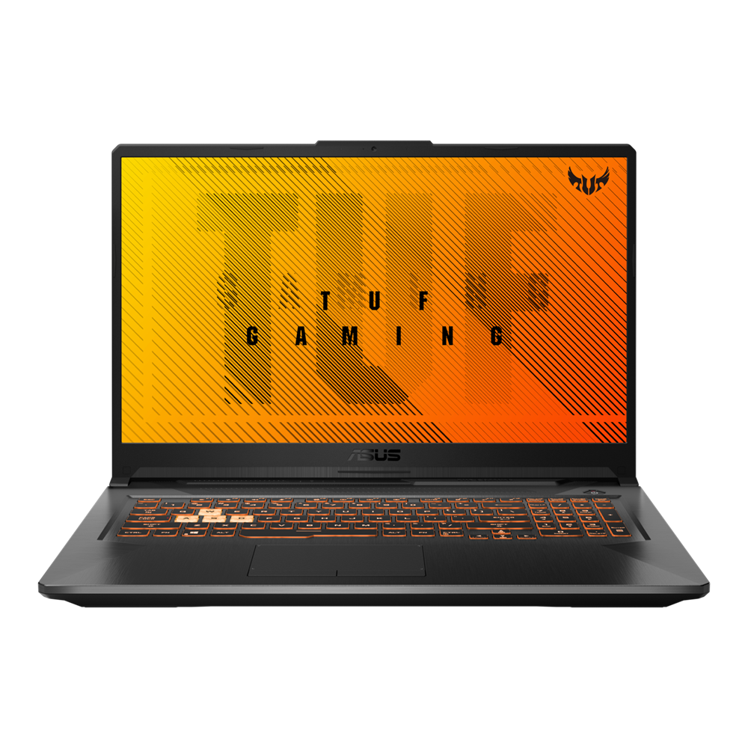

Model : TUF Gaming A17

Color : Black

Brand : ASUS